HPC O-Ring kits
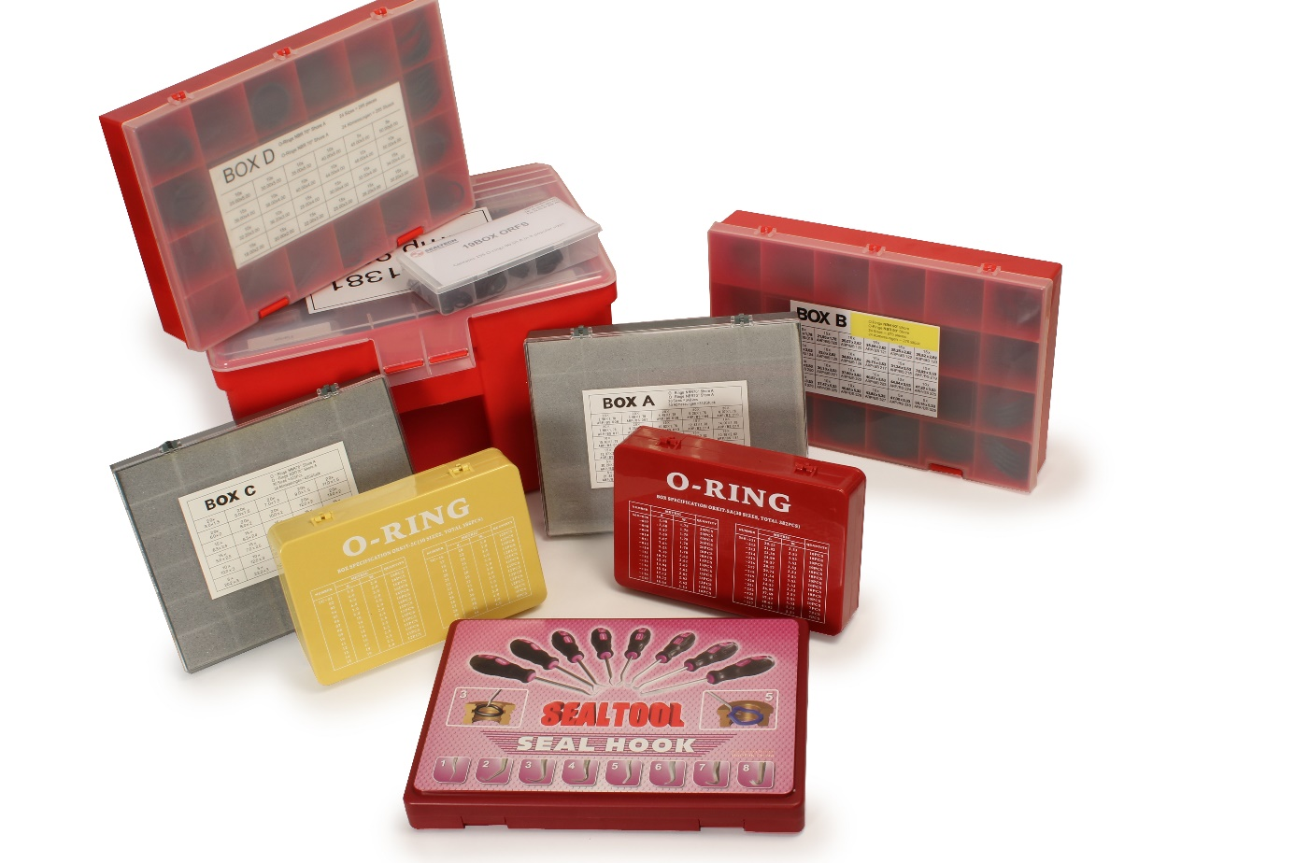

Engrenages HPC increases its innovative offering by adding a yet another new range to its catalogue. Used in mechanical and hydraulic engineering and other industrial applications, O-rings ensure the sealing of two interdependent parts. To meet the requirements of maintenance teams in these industries, HPC now offers several different O-ring kits:
- 6 nitrile (NBR 70 Shore) O-ring kits containing from 275 to 425 rings in up to 30 different sizes.
- 1 kit of nitrile (NBR 90 Shore) O-rings containing 155 rings in 8 sizes.
- 1 large case containing 5 boxes of NBR 90 Shore O-rings with a total of 1,415 parts in 78 sizes.
- 1 D-RING NBR 90 Shore gasket set for flange containing 80 parts in 9 sizes.
- 1 set of imperial sized NBR 90 Shore O-rings for bolts and fittings which contains 114 rings in 7 sizes.

Also included in this range is a set of 8 tools for removing O-rings.

